**John Maynard Keynes**

* Key ideas:

1. Aggregate demand determines the overall level of economic activity
2. Aggregate demand can fluctuate based on “confidence” and “expectations”
3. Free markets therefore won’t always provide full employment in the short run
4. The Government’s policies that affect the level of spending can be used to reduce or eliminate output gaps
5. The Keynesian model is only applicable to the relatively short period during which firms meet the demand at present markets prices

**Actual Aggregate Expenditure and Planned Aggregate Expenditure (PAE)**

* 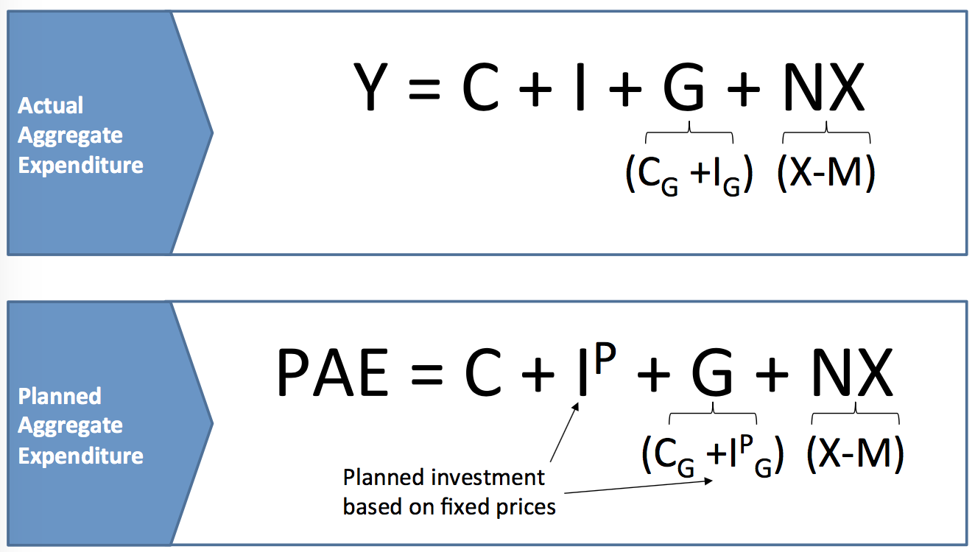
* Planned expenditure can differ from actual spending due to inventory investment.
* A firm’s actual inventory investment is comprised of planned inventory investment and unplanned inventory investment.

1. Planned investment (IP)

--- If sales were less than expected, unsold stock remained in the warehouse, causing actual investment (I) to exceed planned investment (IP) --- I > IP

--- If sales were more than expected, there is a run-down of stocks in the warehouse, causing actual investment (I) to fall below planned investment (IP) --- I < IP

**Consumption function**

* Consumption function:C = C + c(Y – T)
* Exogenous consumption, C, is the level of consumption independent of the income but related to wealth / The portion of planned aggregate expenditure that is independent of output
* Induced consumption, c(Y - T), is the level of level of extra consumption induced by extra disposable income / The portion of planned aggregate expenditure that depends on output
* Disposable income, (Y – T), is the after-tax income.
* The parameter, c, is marginal propensity to consume (MPC) or a measure showing how each extra dollar would be partly spent and partly saved.
* Eg. PAE = 980 + 0.8Y

--- The exogenous expenditure is 980

--- The induced expenditure is 0.8Y

* Y axis: Household’s consumption spending, Cd

X axis: Disposable income, Y-T.

Vertical intercept: exogenous component of consumption, C

Slope: Marginal propensity to consume, c

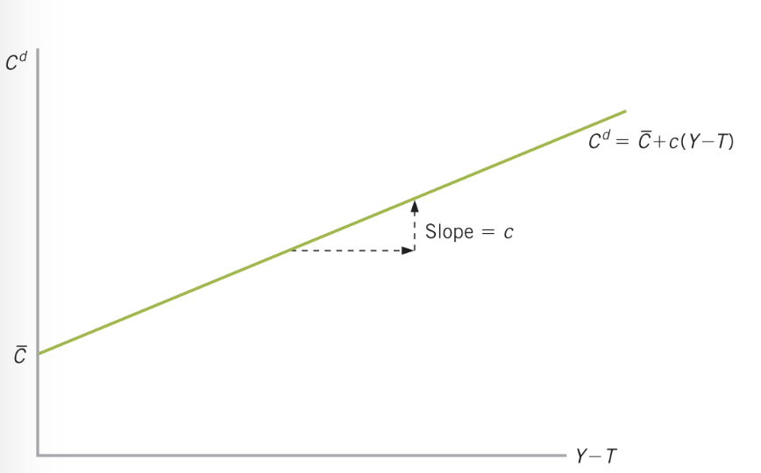

**The Keynesian Cross**

* Studies how “planned expenditure” can differ from “actual output”, which underpins the movements in aggregate demand which cause negative output gaps (“recessions”)

**Simple model: Two sectors model**

* 

--- Consumption: Household will consume a fixed amount (basic living expenses) and then share of whatever else is produced. Tax = 0

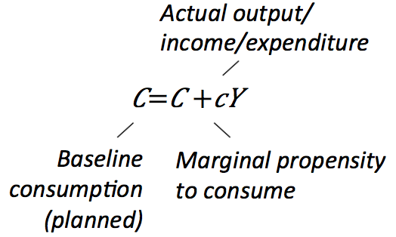

--- Planned investment: will be based on existing (fixed) prices, and interest rates. If actual output is higher than planned expenditure, then firms will build up (“Invest in”) inventories more than planned, and vice versa.

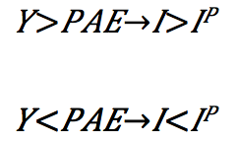

* 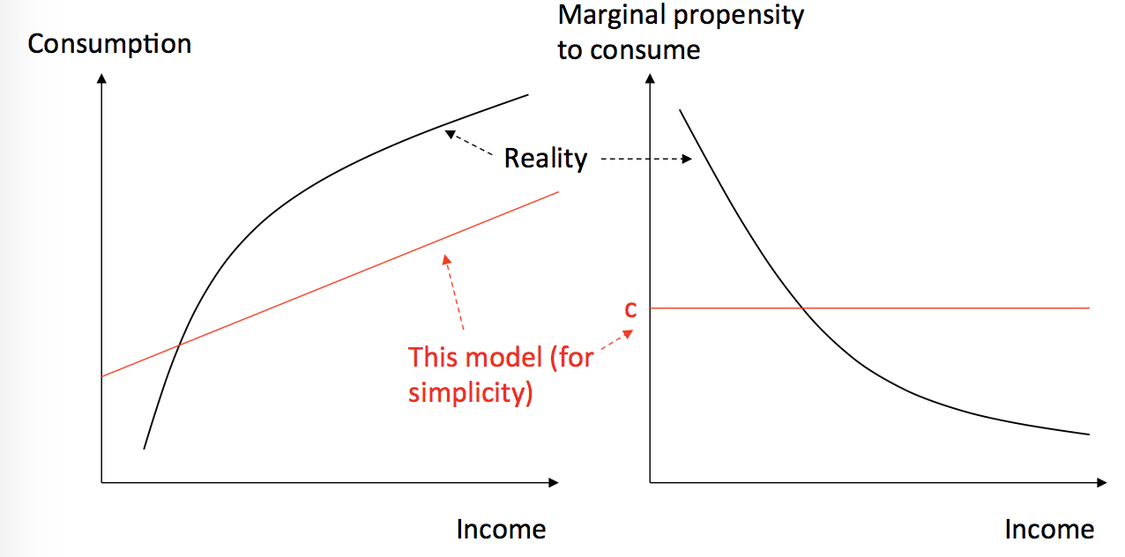

--- However in reality the marginal propensity to consume is lower for people with lower income, which redistribute income from the rich to the poor --- it stimulates the economy because they will spend it

* Savings in the two-sector model:

Saving function can be derived from: 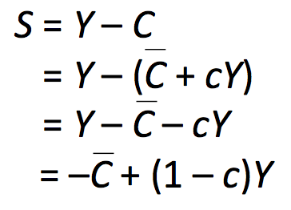

The intercepts of C and –C can be thought of like this: if no income was being earned in the economy, a certain level of consumption, C, would occur, funded through running down savings.

* The components of PAE (two-sector economy)

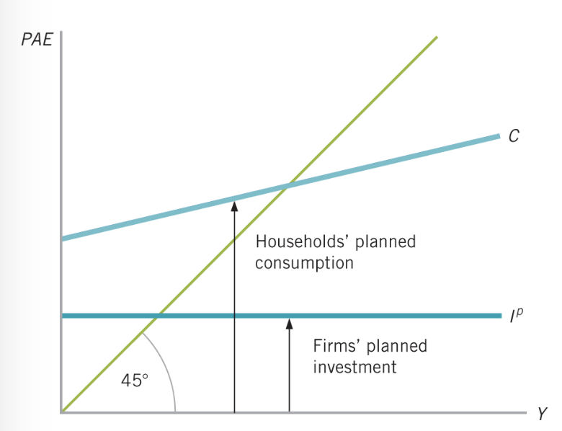

* In this model planned expenditure is just consumption plus planned investment, which can be expressed on the Keynesian Cross

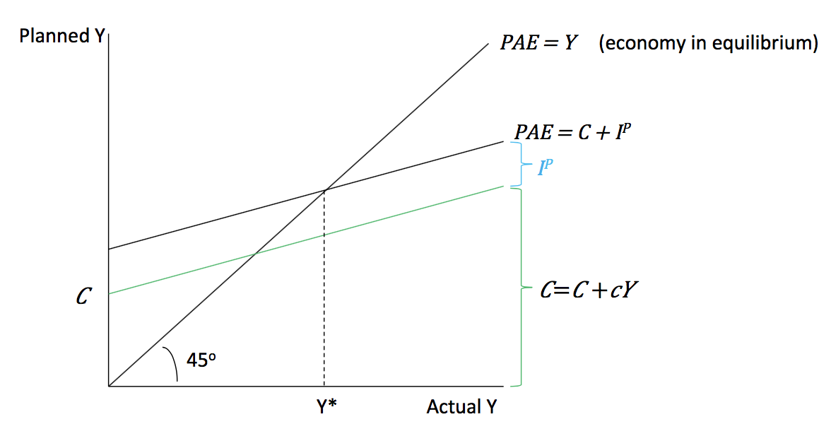

--- C and IP are “exogenous” variables (pre-determined outside the model)

--- C is “endogenous” variable (determined within the model)

* If actual output is above planned output, firms will accumulate inventories (investment), until the economy is in equilibrium again.

--- If Y>PAE: Firms produce more than was planned. The extra output will be stored in inventories, which counts as higher-than-planned investment, I > IP. Firms will there produce less, providing less income to households, so they consume less (C falls) , until the economy is back in equilibrium.

--- If Y<PAE: Firms produce less than was planned. The opposite happens.

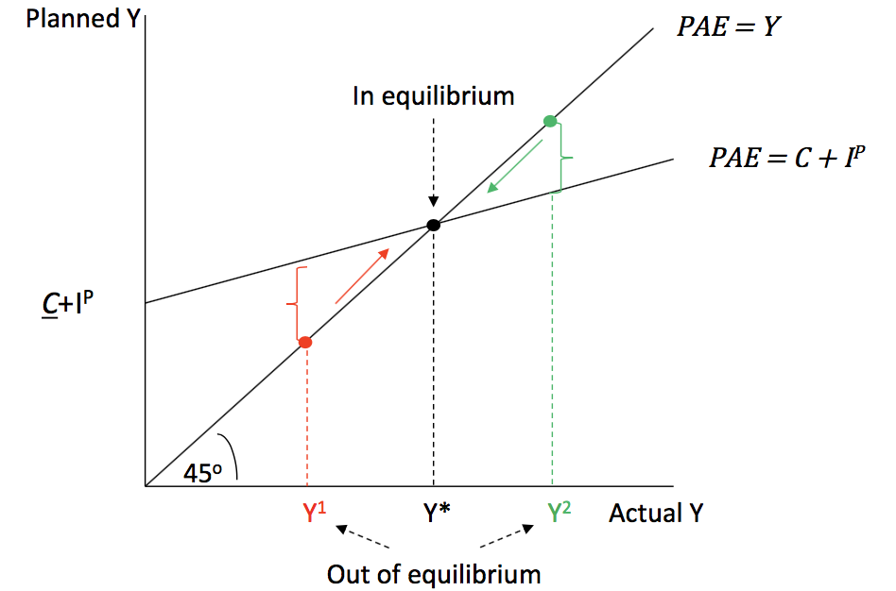

* Planned expenditure might fall because interest rates rise (IP), house prices/household wealth falls (C), or consumer confidence falls (C). And since prices are sticky, this creates a contraction (and unemployment)

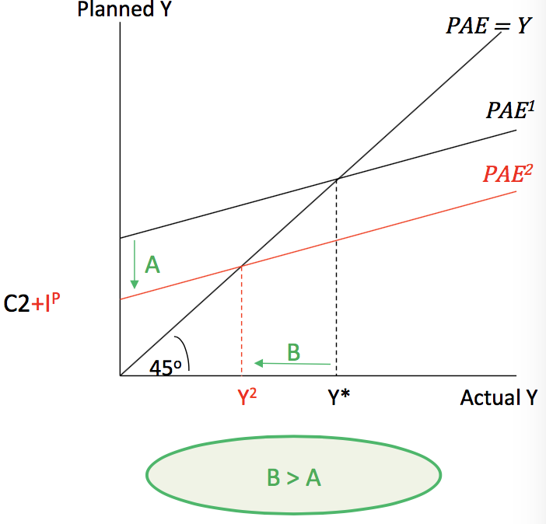The Keynesian Multiplier

A fall in exogenous consumption of A causes a larger fall in aggregate output B, because it also reduces household income (Y), which in turn reduces endogenous consumption:

PAE = C + Cy + IP

Along the 45o line:

PAE = Y

Therefore:

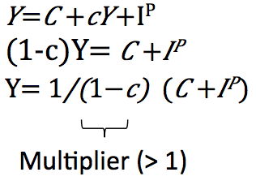

--- Eg. If decrease exogenous consumption by 10 units,

impact on economy would be 10 * 1/(1-c) = 10 * 5 = 50

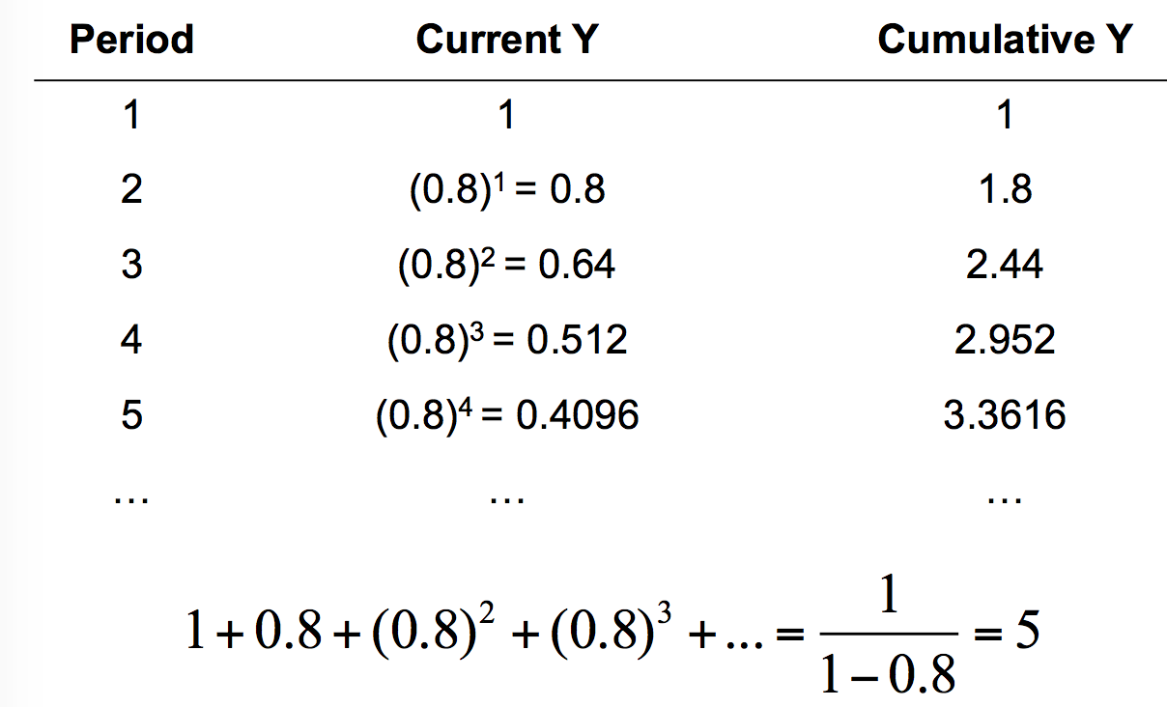

--- decrease in exogenous consumption --- decrease in labour / producer income etc

* If everyone spontaneously (exogenously) starts saving, output will contract, so total savings won’t change (Keynes’ “Paradox of Thrift”), but the output of economy will decrease

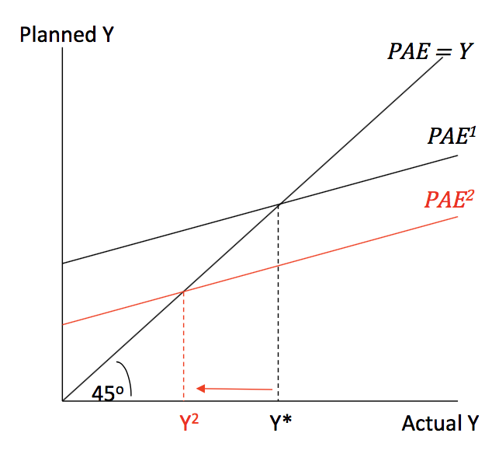

The Paradox of Thrift

Savings is income that isn’t consumed:

S = Y – C

However, income is just consumption + investment:

Y = C + IP

Therefore, in this closed economy saving must equal investment:

If C falls, both output (Y) and consumption (C) fall by the same amount, so aggregate saving doesn’t change because IP doesn’t change.

**Simple model: Alternative**

* 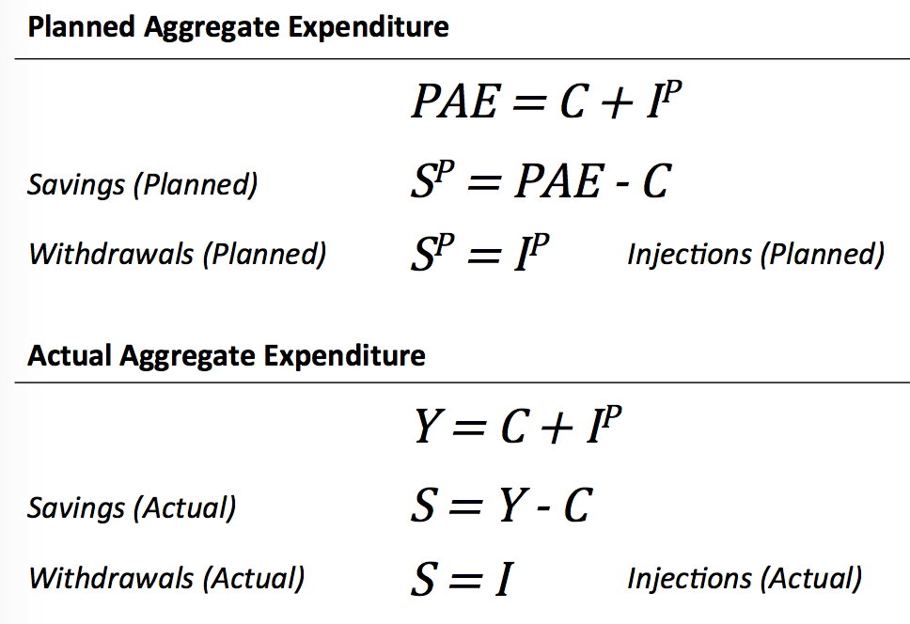We can also express exactly the same ideas in a different way, in terms of withdrawals (eg. savings) and injections (eg. Investment) of expenditure

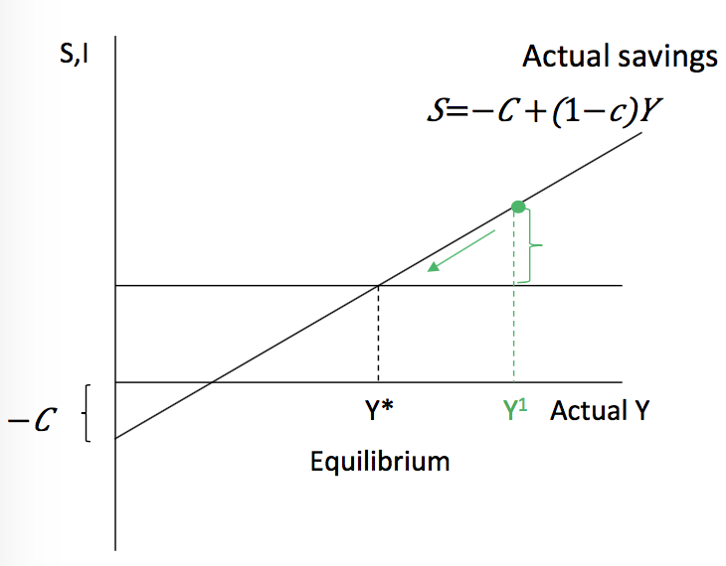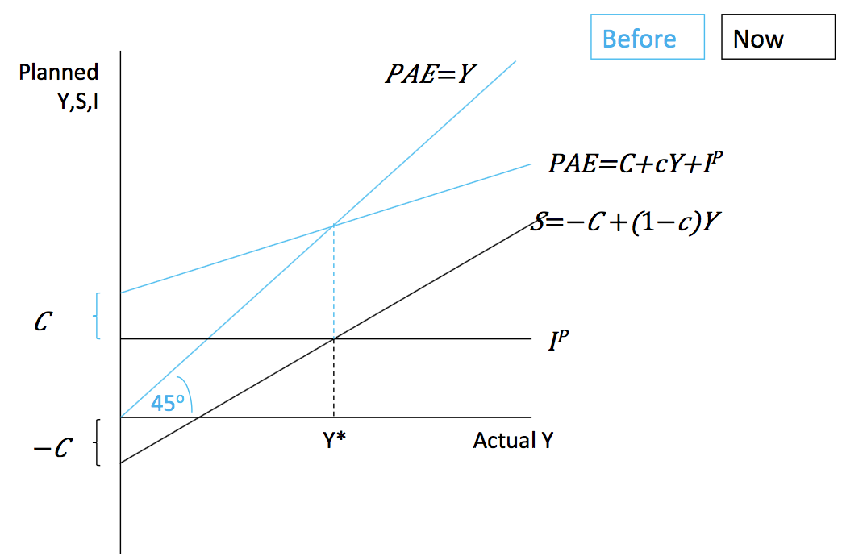

* when Y= PAE --- Equilibrium

when Y > PAE:

1. Output is above equilibrium
2. More is produced than planned
3. Extra output will be accumulated in inventories
4. S and I > IP
5. Withdrawals > Injections
6. Output will fall back to equilibrium

**Detailed model: 4 sectors**

* 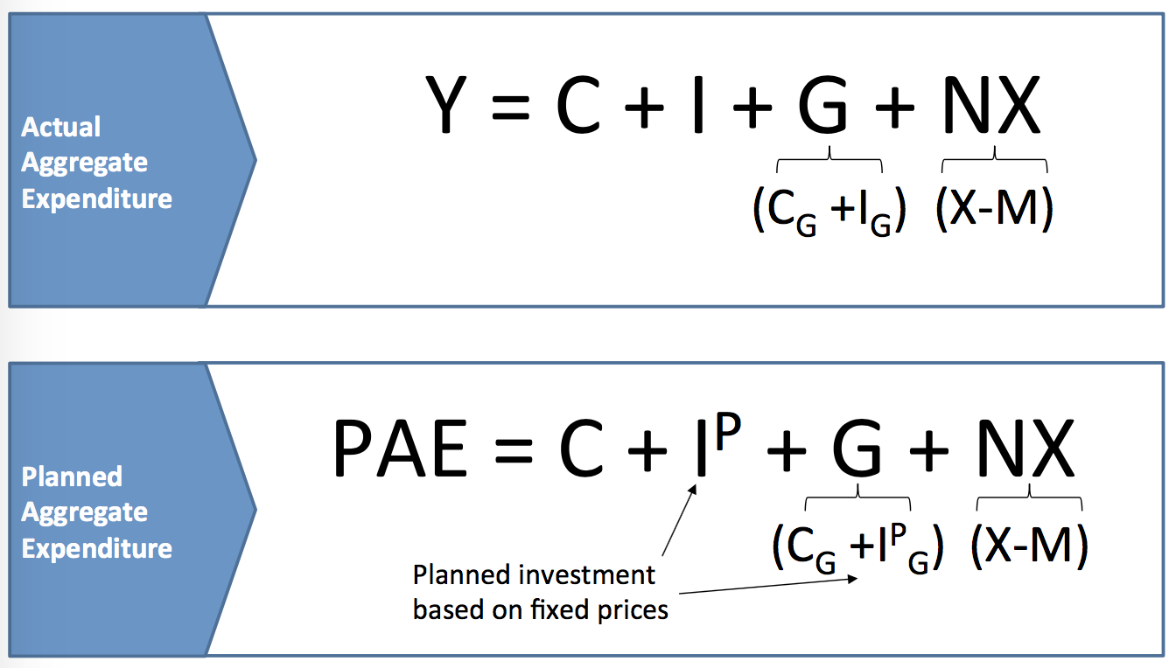
* Assume investment is fixed, I = IP and the government only consumers, G = CG, IG = 0

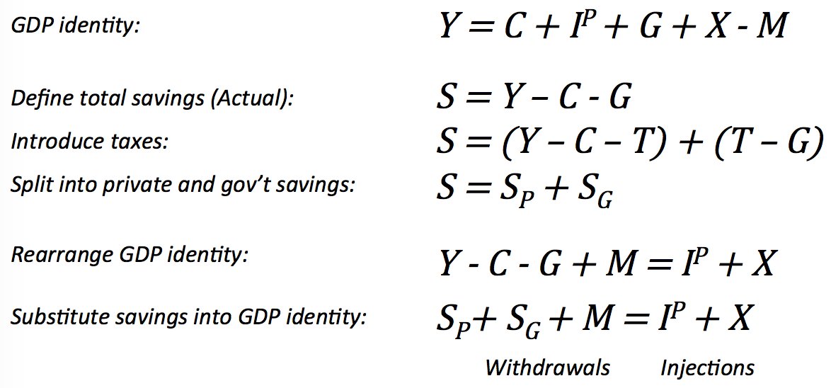

* Injections and withdrawals:
* For equilibrium to occur, any injections of expenditure into the economy are exactly matched by any withdrawal of expenditure from the economy.
* Injections (INJP) refer to all sources of exogenous expenditure in the economy.
* Withdrawals (WD) refer to that part of income not used for consumption purposes.
* The economy’s national income which can be equivalently measured using the production, expenditure or income approaches.
* Short-run equilibrium output: 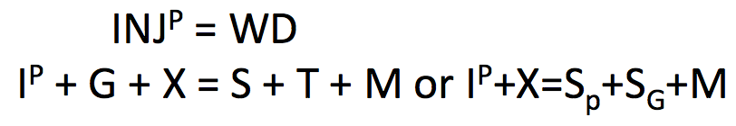
* Domestic consumption:

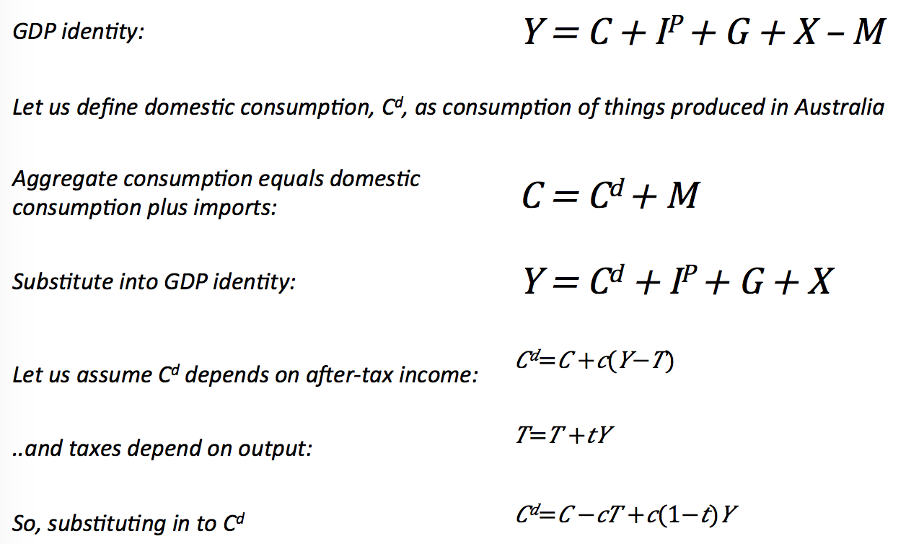

* Express the 4 sector model on the Keynesian Cross:

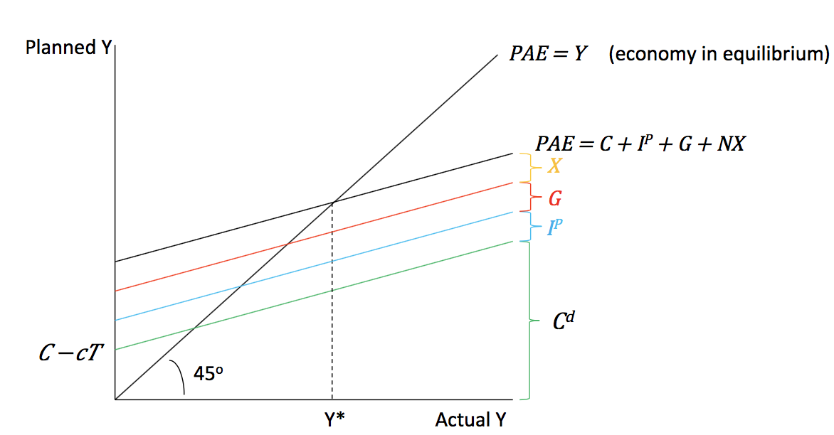

C, T, IP, G and X are “exogenous” variables (pre-determined outside the model)

C is an “endogenous” variable (determined within the model)

c and t are parameters

* If there is a collapse in private demand, which causes a contraction, government can spend more to fill the gap in demand:

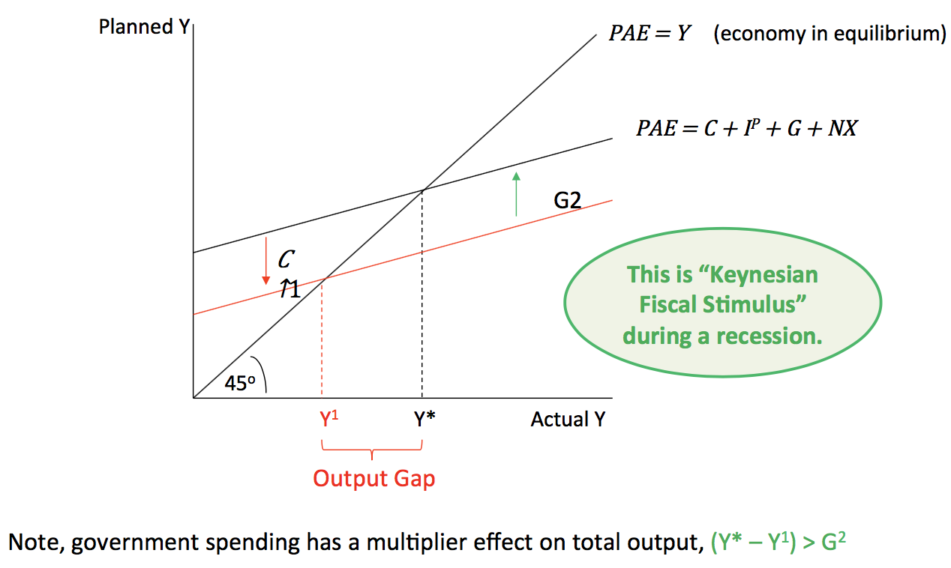

The central bank can also lower interest rates to boost consumption and investment:

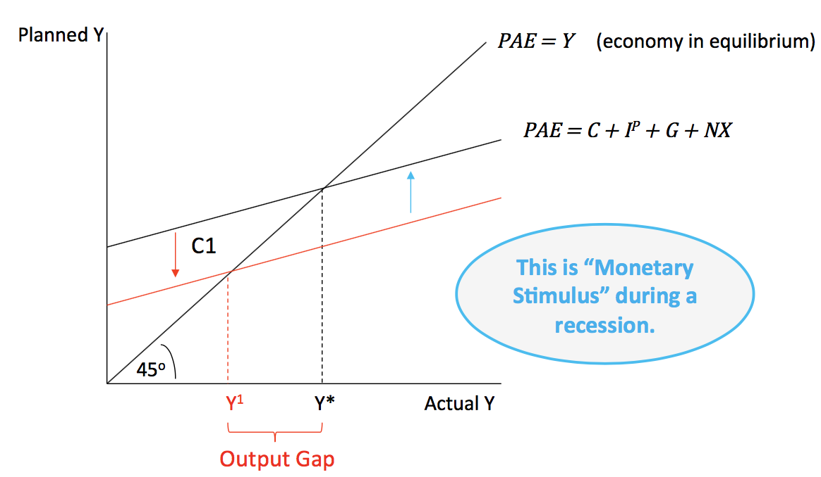

Q:

5.1 What is the key assumption of the basic Keynesian model?

5.2 What are the four components of the economy’s planned aggregate expenditure?

5.3 What is the consumption function?

5.4 In what way is planned aggregate expenditure linked to aggregate output?

5.5 What is meant by equilibrium output?

* Fiscal Policy

Government purchases and planned spending

Fiscal Policy

* Two main components of fiscal policy are:
* Government purchases
* Taxes and transfer payments

Reasons for Australia to skip global financial crisis

* A stable housing market
* A robust financial system
* Strong export performance to China and India
* Aggressive coordinated fiscal and monetary policy response